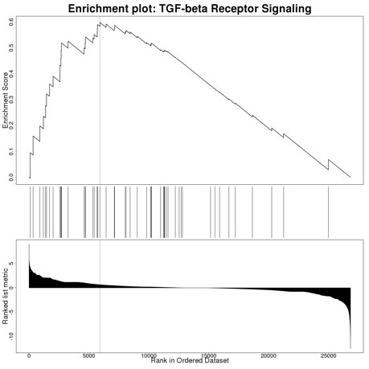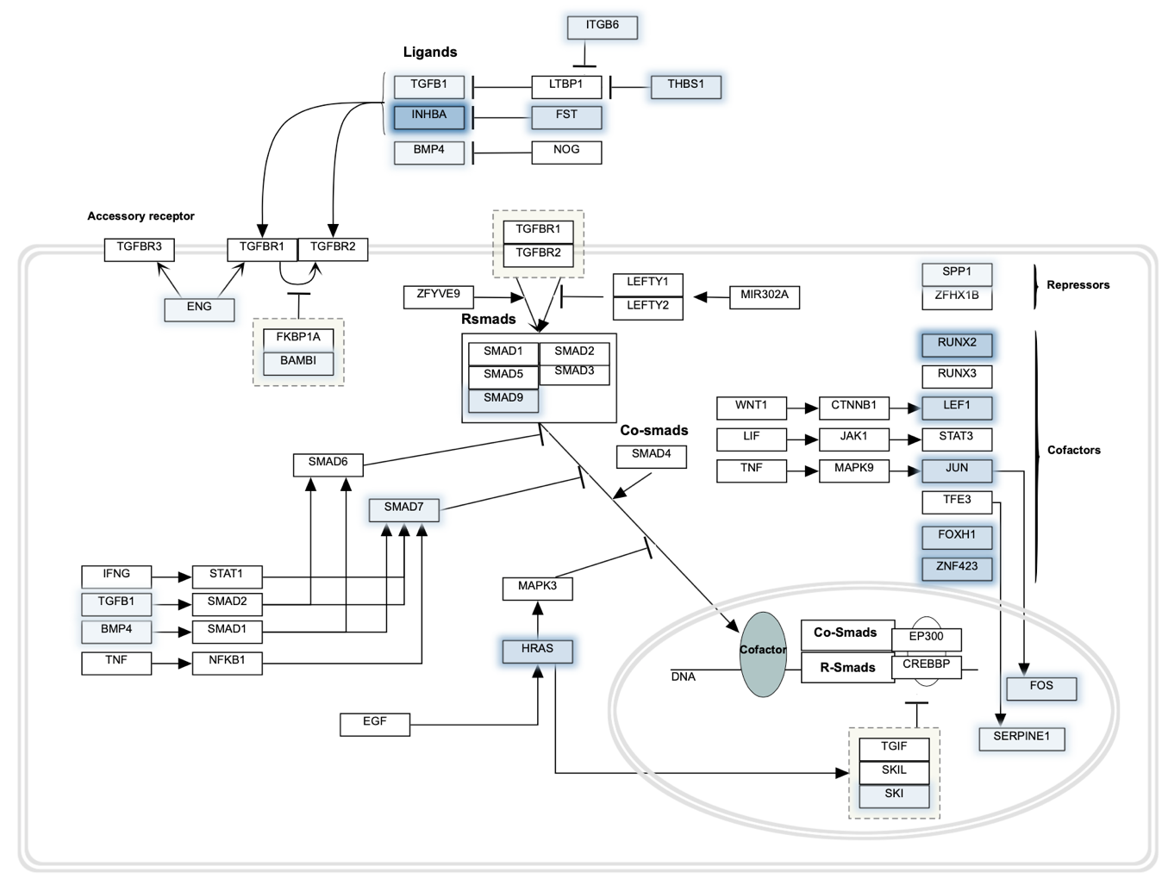
Supplementary Figure 7. TGF-beta Receptor Signaling (gene set: WP560). Genes highlighted in blue are upregulated in nutlin-3 resistant A549.R2 cells

