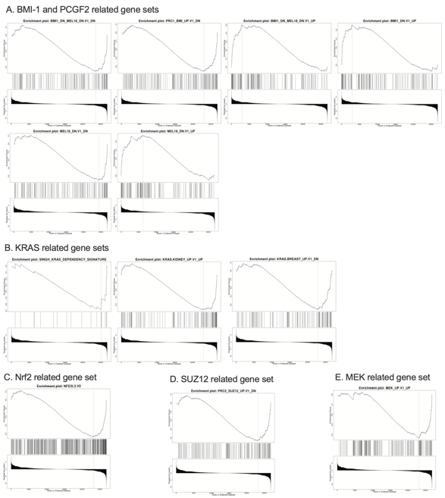
Supplementary Figure 6. Overview of oncologic gene expression signatures. (A) Gene signatures related to BMI-1 and/or PCGF2 knockdown (gene sets: M2775, M2730, M2779, M2784, M2783, M2784). (B) Gene expression signatures related to KRAS (M2851, M2892, M2887). (C) Gene expression signature related to Nrf2 activation (M2870). (D) Gene expression signature related to SUZ12 knockdown (M2740). (E) Gene signature related to MEK activity (M2725). FDR ≤ 0.05, p-value ≤ 0.05

