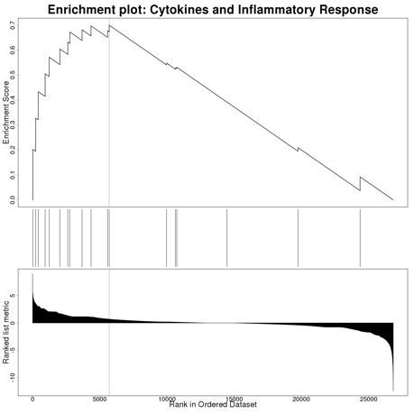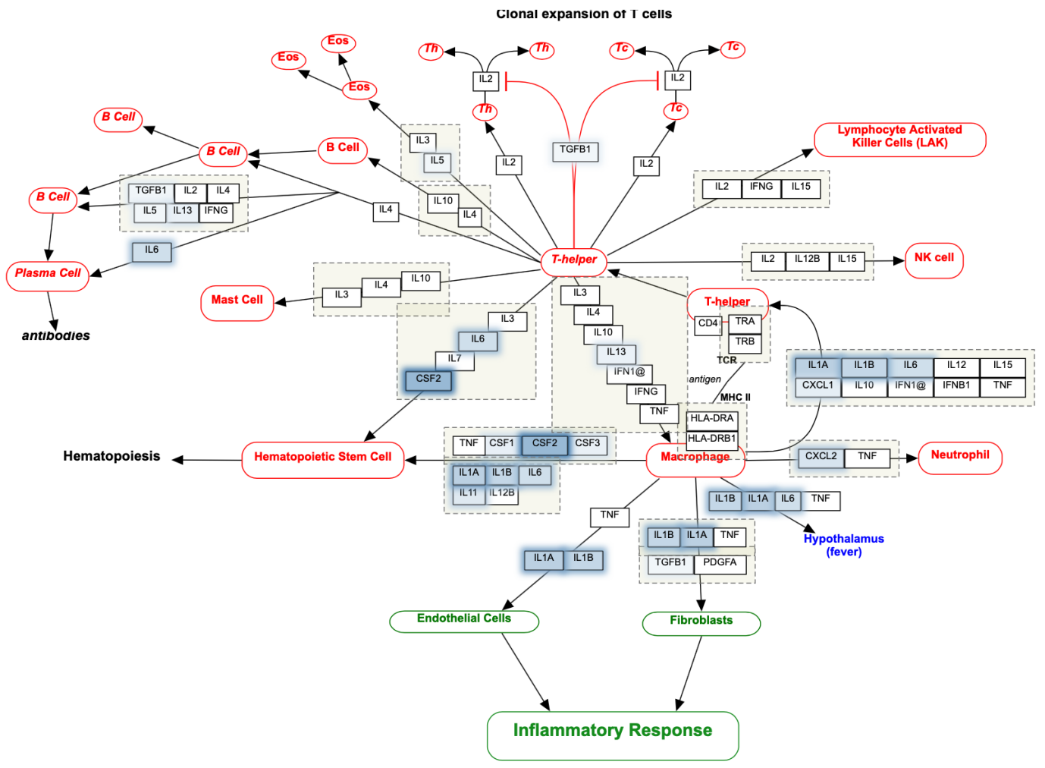
Supplementary Figure 5. Cytokines and inflammatory response (gene set: WP530). Genes highlighted in blue are upregulated in nutlin-3 resistant A549.R2 cells

