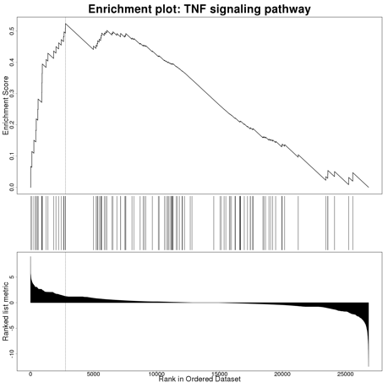
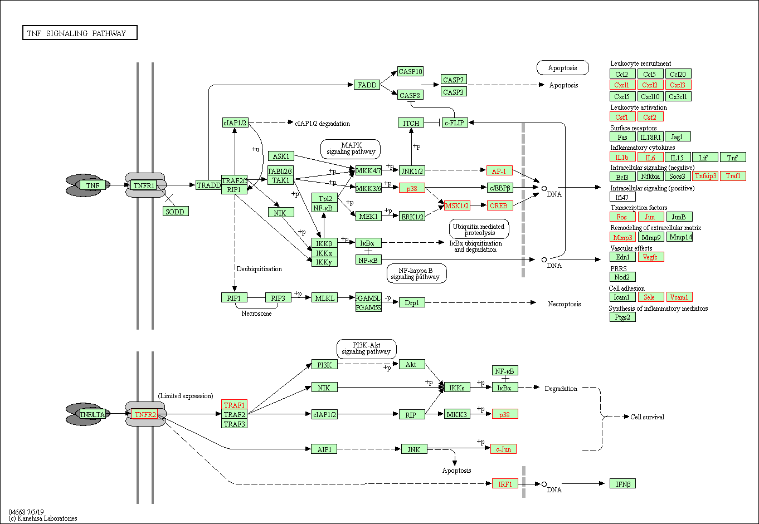
Supplementary Figure 4. TNF signaling pathway (gene set: hsa04668). Genes highlighted in red are upregulated in nutlin-3 resistant A549.R2 cells

