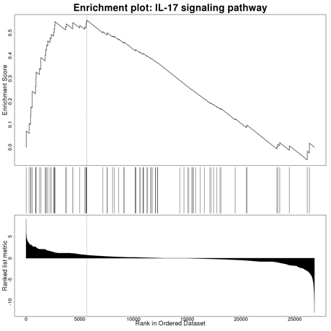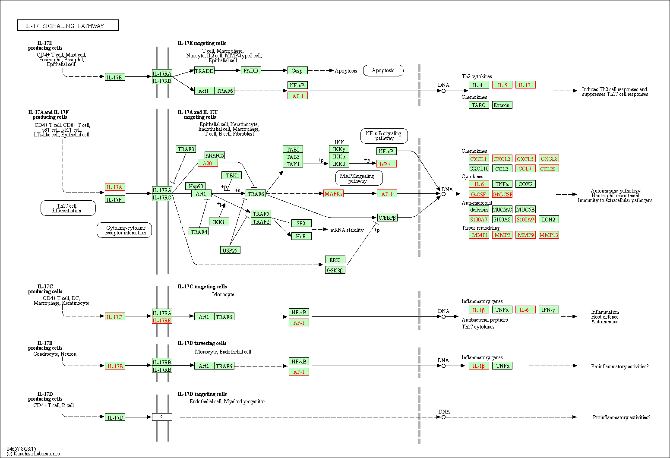
Supplementary Figure 3. IL-17 signaling pathway (gene set: hsa04657). Gene highlighted in red are upregulated in nutlin-3 resistant A549.R2 cells

