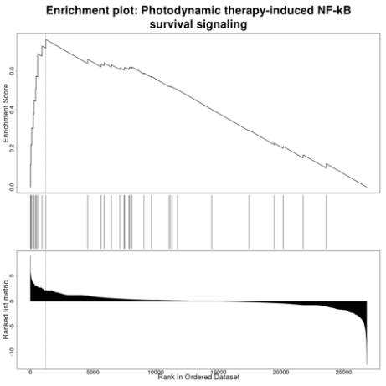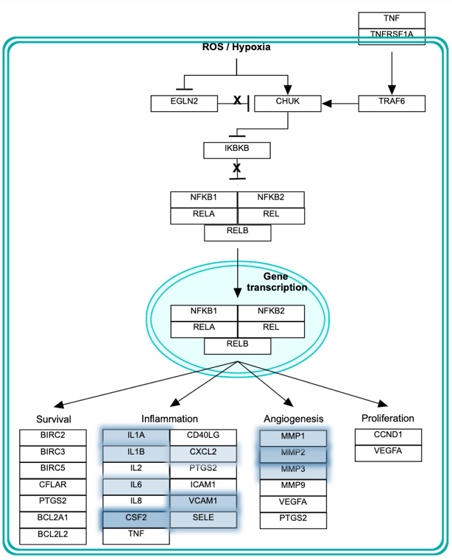
Supplementary Figure 2. Photodynamic therapy-induced NF-kB survival signaling (gene set: WP3617). Genes highlighted in blue are upregulated in nutlin-3 resistant A549.R2 cells

