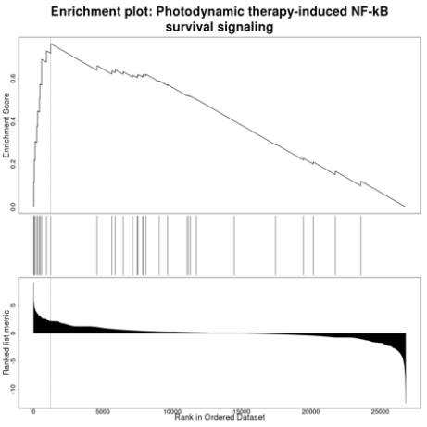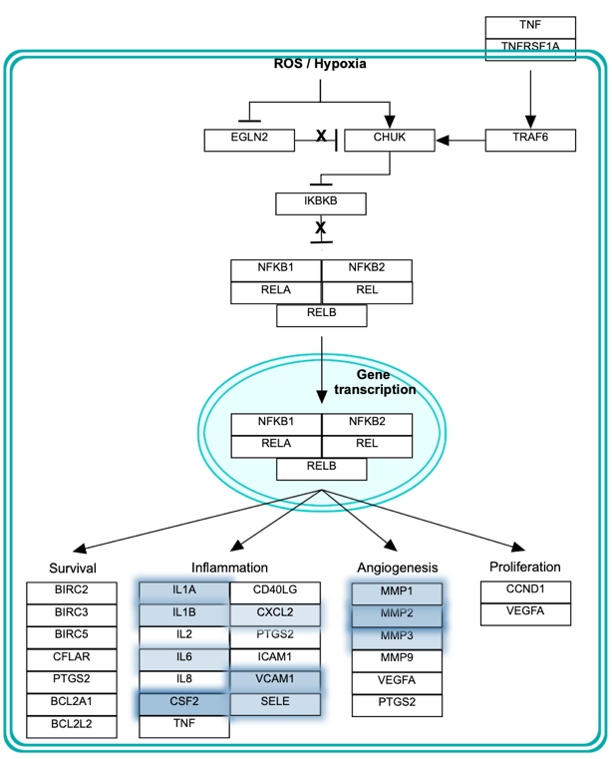
Supplementary Figure 2. Photodynamic therapy-induced NF-kB survival signaling (gene set: WP3617). Genes highlighted in blue are upregulated in nutlin-3 resistant A549.R2 cells

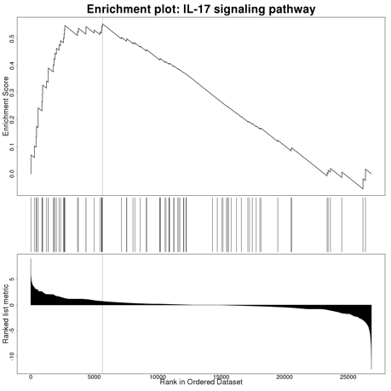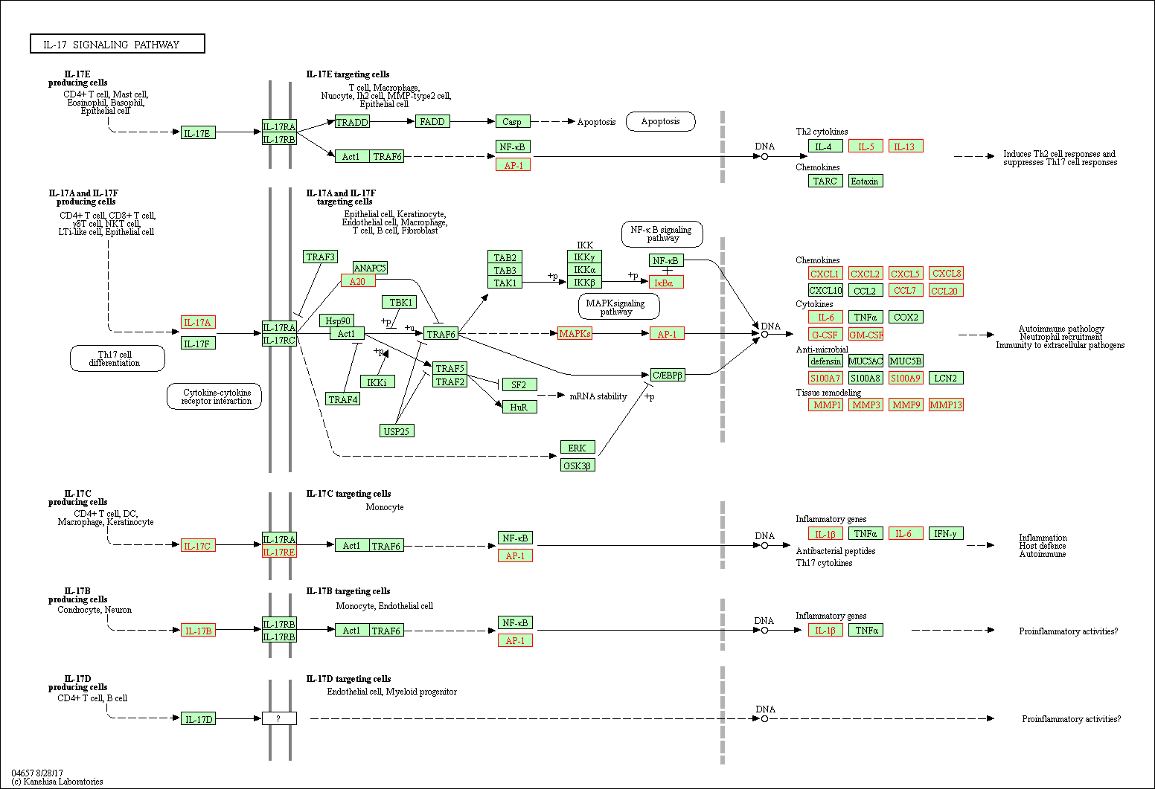
Supplementary Figure 3. IL-17 signaling pathway (gene set: hsa04657). Gene highlighted in red are upregulated in nutlin-3 resistant A549.R2 cells

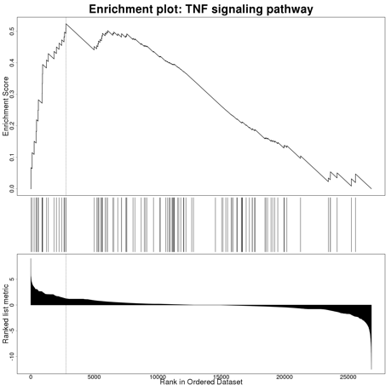
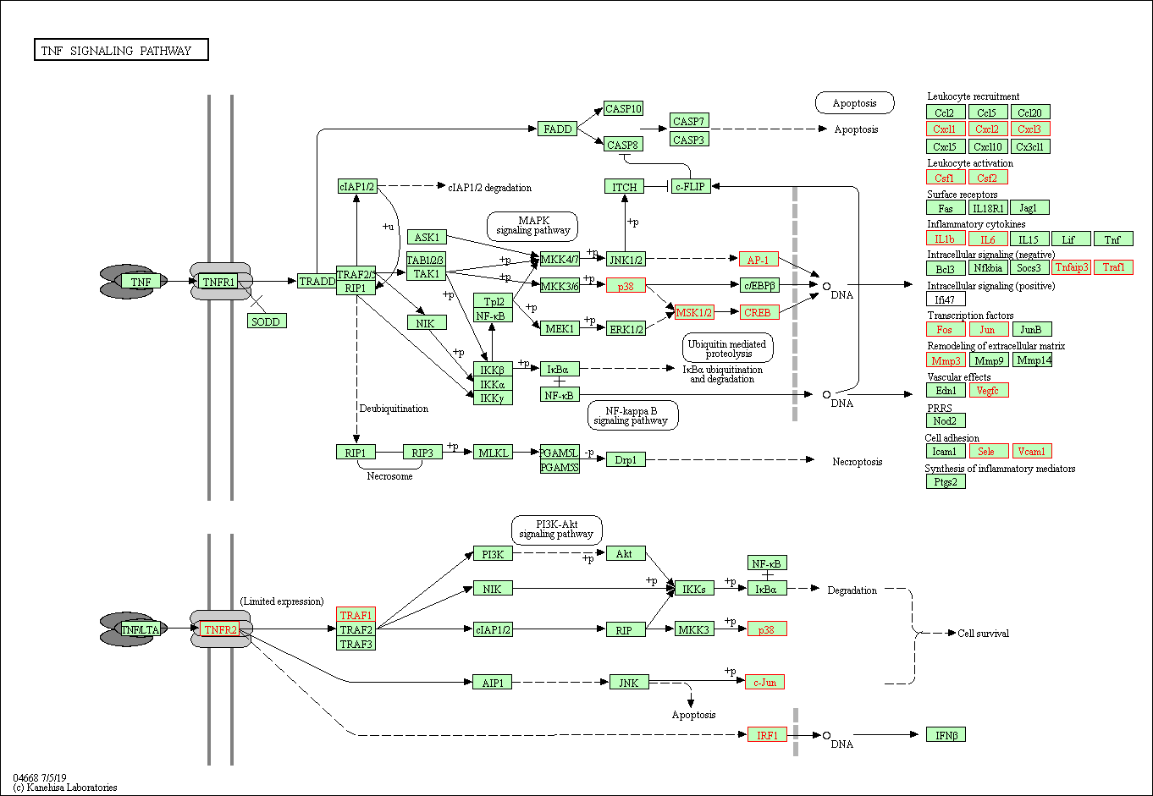
Supplementary Figure 4. TNF signaling pathway (gene set: hsa04668). Genes highlighted in red are upregulated in nutlin-3 resistant A549.R2 cells

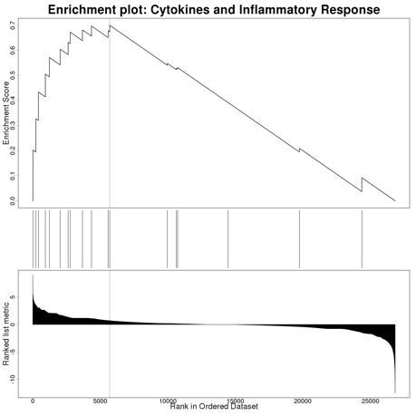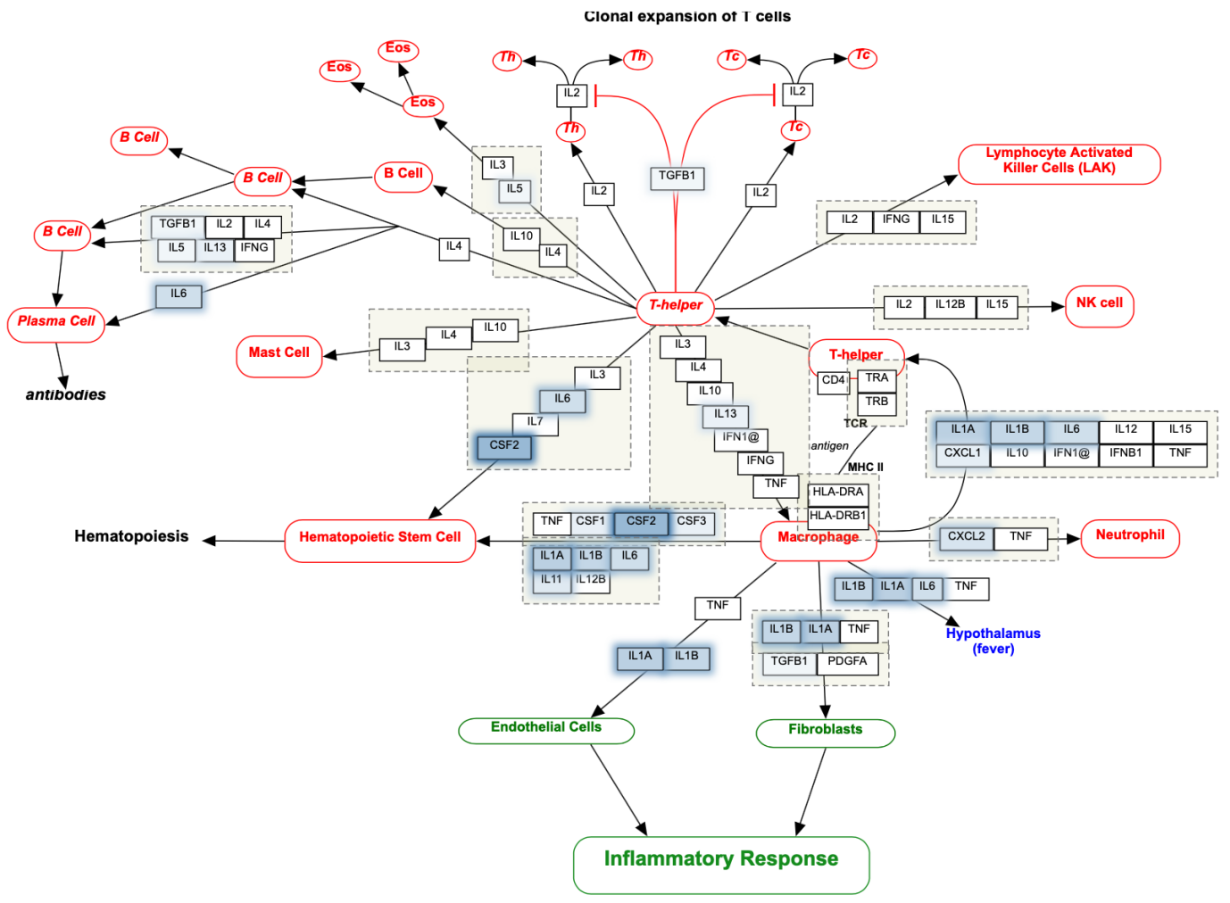
Supplementary Figure 5. Cytokines and inflammatory response (gene set: WP530). Genes highlighted in blue are upregulated in nutlin-3 resistant A549.R2 cells

